DEPARTMENT OF STATISTICS
FACULTY OF SCIENCE
MULTIVARIATE ANALYSIS -II (M.SC. SEM 2)
PRACTICAL6 -Multivariate analysis of variance
Date: 05/03/2026 Day: Thursday

Q1. Nursing homes can be classified on the basis of ownership (private party, nonprofit organization, and government) and certification. One purpose of a recent study was to investigate the effects of ownership Or certification (or both) on costs. Four costs, computed on a per-patient-day basis and measured in hours per patient day, were selected for analysis:
XI = cost of nursing labor,
X2 = cost of dietary labor,
X3 = cost of plant operation and maintenance labor,
X4 = cost of housekeeping and laundry labor.
A total of n = 516 observations on each of the p = 4 cost variables were initially separated according to ownership. Summary statistics for each of the g = 3 groups are given in the following table.
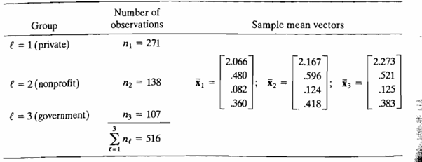

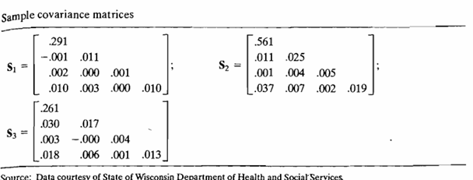
Q2. (A two-way multivariate analysis of variance of plastic film data) The optimum conditions for extruding plastic film have been examined using a tech nique called Evolutionary Operation. (See [9].) In the course of the study that was done, three responses-
X₁ = tear resistance,
X₂ = gloss,
X₃ = opacity
were measured at two levels of the factors, rate of extrusion and amount of an additive. The measurements were repeated n = 5 times at each combination of the factor levels.
